**TABLE OF CONTENTS**

**TOPICS. Page no.**

1. Introduction 3
2. Case Study 3
3. ER Diagram 4
4. Normalization 5
5. Finalization 16
6. Table Description & Data Insertion 18
7. Query 34
8. Conclusion 36

**Introduction:**

The purpose of this project is to design and implement a university database management system that can store and manage information about employee, student, professor and other relevant data. the system is designed to support a small-scale university with the potential for scalability in the future.

**Case study:**

In a university management system, the management has many employees. Employees have a unique employee id. Employee name, DOB, salary, address, rank and phone number are also stored. Management is identified by ID, name, rank and division. Employee name is composed of first name and last name. Professor is an employee. A professor is identified by a professor id. Each professor also have their name, dob, salary, address, title, department and phone number stored. Address consists of city and house no. Many professors might manage one department. Each department has its name and a unique id stored. Under one department there might be many programs. Program id and name is stored. In a program there are many courses. Courses are identified by a course id. Also name and credits of each course are stored. One course may be included in many programs. Many professors may take many courses. Management enrolls many students. A student is identified by an id number. Also, student name, address, phone number, program, enroll date, DOB and CGPA are stored in database. Student names are composed of first name and last name. A student is taught by many professors. A professor may teach many students. A student can enroll in only one program. A program may have many students. A student can obtain a degree which is awarded by the management. Degree has a unique name. degree type is also stored in the database.

**ER Diagram:**

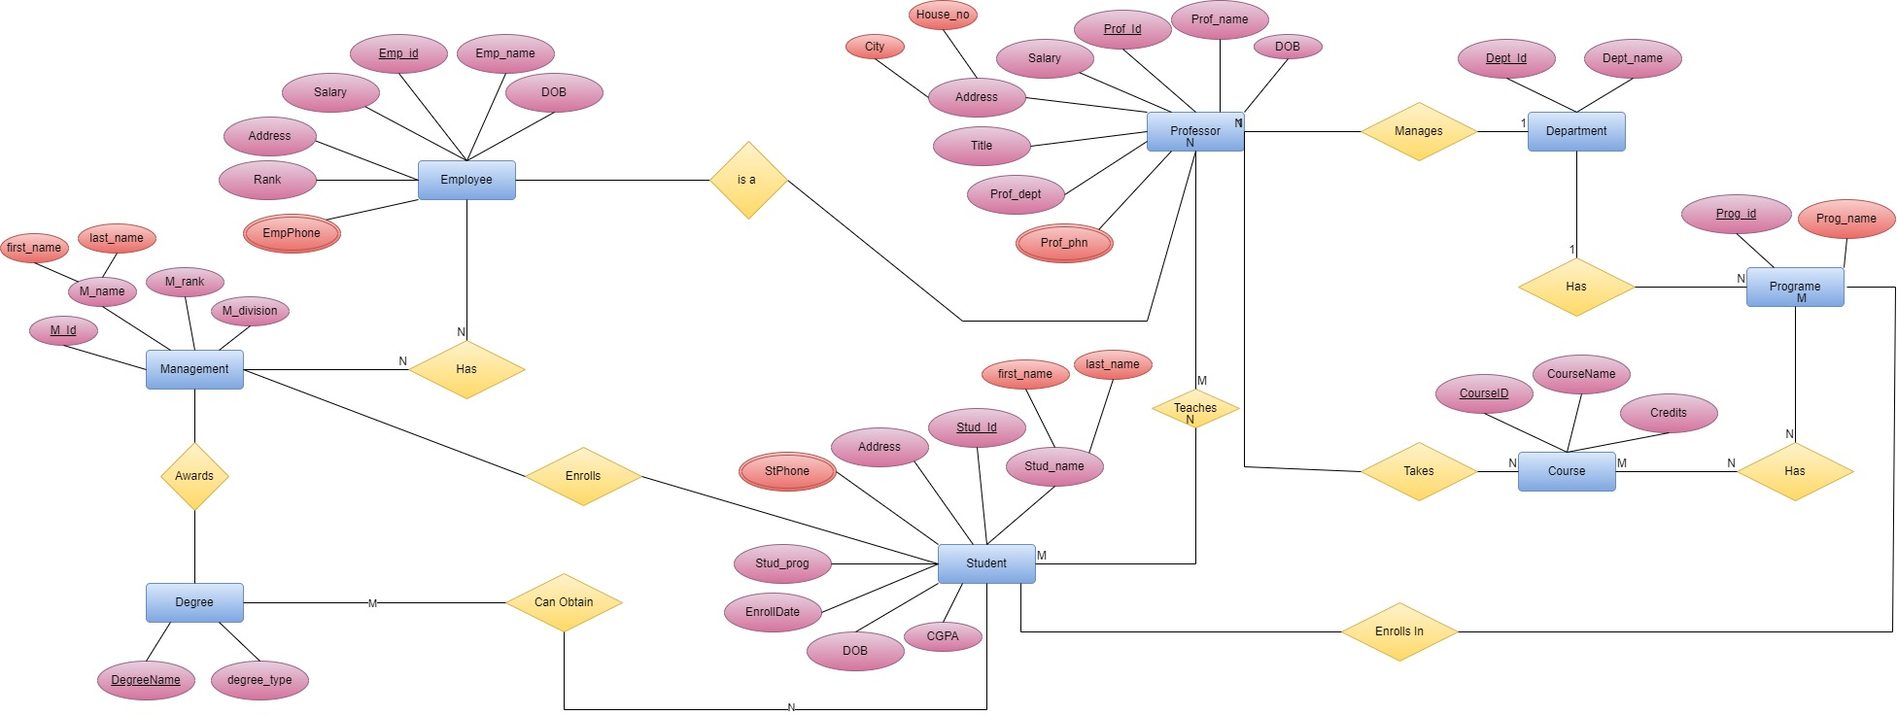

**NORMALIZATION**

1. **Relation: One to one**

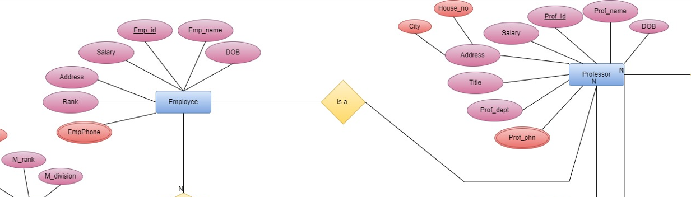

**UNF:** Emp_ID, Emp_Name, Emp_DOB, Salary, Address, Rank, Emp, Phone, prof_phone, prof_dept, prof_title, prof _address, prof_salary, prof _ID, Prof_Name, prof_DOB, city, house_no

**1NF:**

Multivalued Attribute: Emp_Phone, Prof_Phone

**2NF:**

1. Emp_ID, Emp_Name, Emp_DOB, EMP_Salary, Rank, Emp_Dept
2. Emp_Phone, Emp_ID
3. Prof_Phone, Prof _ID
4. Prof _ID, city, house_no
5. Prof _dept, Prof_title, prof_address, pf_salary, prof _ID, Prof_Name, prof_DOB

**3NF:**

1. Emp_Phone, Emp_ID
2. Prof_Phone, Prof _ID.
3. Prof_ID, city, house_no
4. Emp_ID, Emp_Name, Emp_DOB, EMP_Address, Emp_Dept.
5. Emp_ID, Emp_salary, Rank.
6. prof _ID, prof_dept, Prof_Name, DOB.
7. Prof_ID, Prof_salary, prof_title.

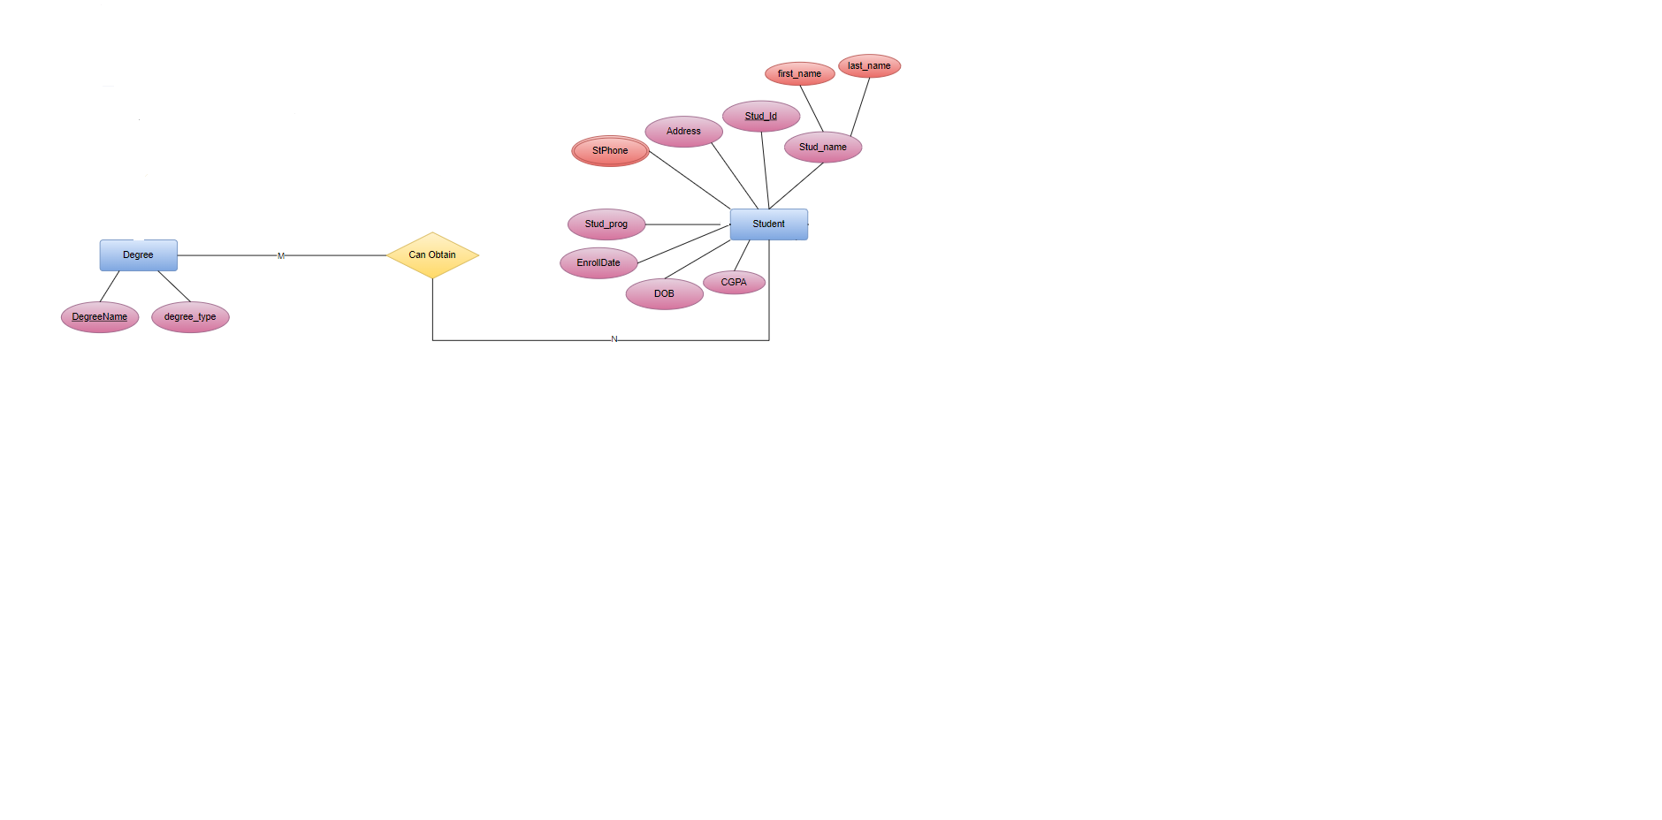**2)Relation: One to one**

**UNF:** type, DegreeName, CGPA, stud_prog, EnrollDate, DOB, StPhone, Address, Stud_id, first_name, last_name

**1NF:**

Multivalued Attribute: St_phone

**2NF:**

1. Stud_id, first_name, last_name, DOB, CGPA, Enrolldate, Stud_prog, Address

2. StuPhone, Stud_id

3. Degree_type, DegreeName

4. Stud_id, DegreeName

**3NF:**

No transitive dependency is available in these tables.

**3)Relation: Many to Many**

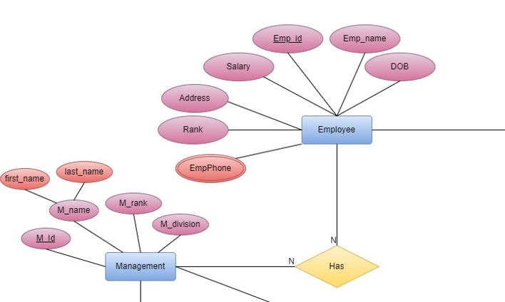



**UNF:** Emp_id, emp_name, DOB, Salary, Address, Rank, Department, EmpPhone, M_id, first_name, last_name, M_rank, M_division.

**1NF:**

Multivalued Attribute: EmpPhone

**2NF:**

1. EmpPhone, Emp_id
2. Emp_id, emp_name, DOB, Salary, Address, Rank, Department.
3. M_id, first_name, last_name, M_rank, M_division.
4. M_id, Emp_id

**3NF:**

1. EmpPhone, Emp_id
2. Emp_id, emp_name, DOB, Address, EmpPhone
3. Salary, Rank, Department, Emp_id
4. M_id, first_name, last_name, M_rank, M_division

**4)Relation: Many to Many**

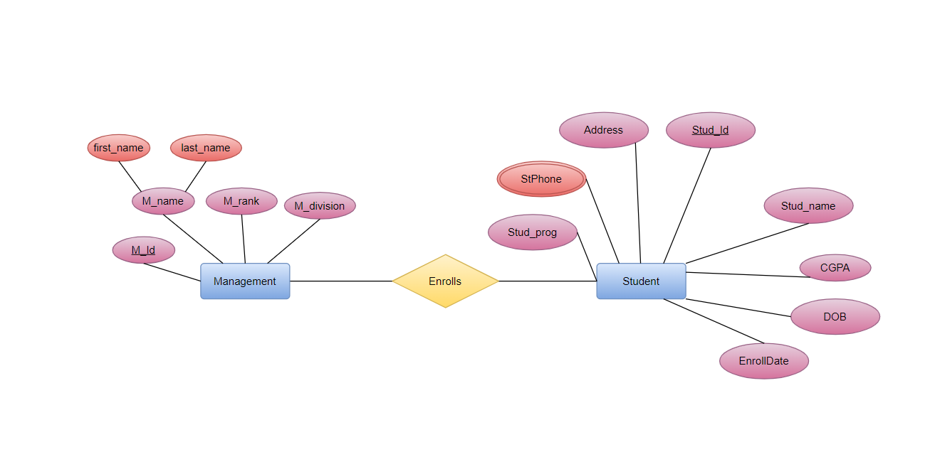

**UNF:** M_id, first_name, last_name,M_rank, M_division, CGPA, Stud_prog, EnrollDate, DOB, StPhone, Address, Stud_id, first_name, last_name.

**1NF:**

Multivalued Attribute: St_phone

**2NF:**

1. Stud_id, first_name, last_name, DOB, CGPA, Enrolldate, Address

2. stPhone, Stud_id

3. M_id, first_name, last_name, M_rank, M_division.

4. M_id, Stud_id

**3NF:**

No transitive dependency is available in these tables.

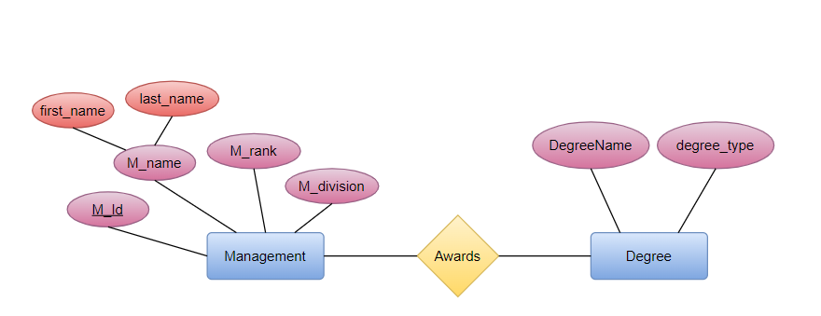**5)Relation: Many to Many**

**UNF:** first_name, last_name, M_id, M_rank, M_division, DgreeName, degree_type

**1NF:**

The tables are already in 1NF.

**2NF:**

1. M_id, first_name, last_name, M_rank, M_division.

2. M_id, DegreeName

3. DegreeName, degree_type

**3NF:**

No transitive dependency is available in these tables.

**6)Relation: Many to Many**

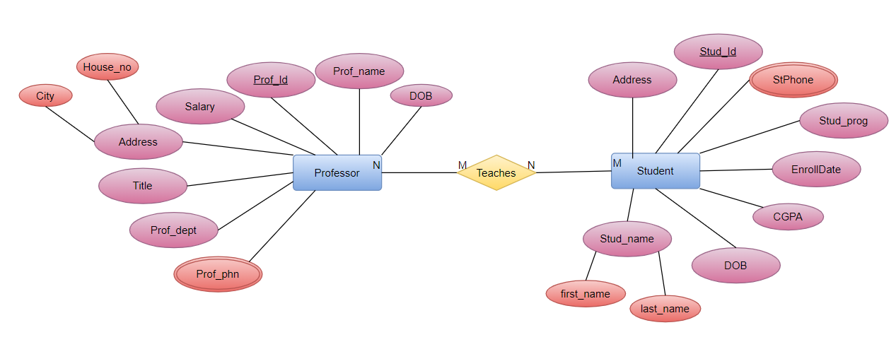

**UNF:** CGPA, EnrollDate, DOB, StPhone, Address, Stud_id, first_name, last_name, pf_phone, prof_dept, pf_title, pf_address, pf_salary, prof_id, Prof_name, DOB, city,

House_no

**1NF:**

Multivalued Attribute: St_phone, prof_phn

**2NF:**

1. Stud_id, first_name, last_name, DOB, CGPA, Enrolldate, Stud_prog

2. StPhone, Stud_id

3. Pf_Phone, prof_id

4. prof_dept, pf_title, salary, prof_id, Prof_name, DOB

5. Stud_id, prof_id

6. prof_id, city, house_no

**3NF:**

1. Stud_id, first_name, last_name, DOB, CGPA, Enrolldate, stud_prog, Address

2. stPhone, Stud_id

3. prof_id, prof_phn

4. prof_id, ProfessorName, DOB, prof_dept, address

5. prof_id, pf_title

6. pf_title, salary

7. Stud_id, prof_id

8. prof_id, city, house_no

**7)Relation: Many to many**



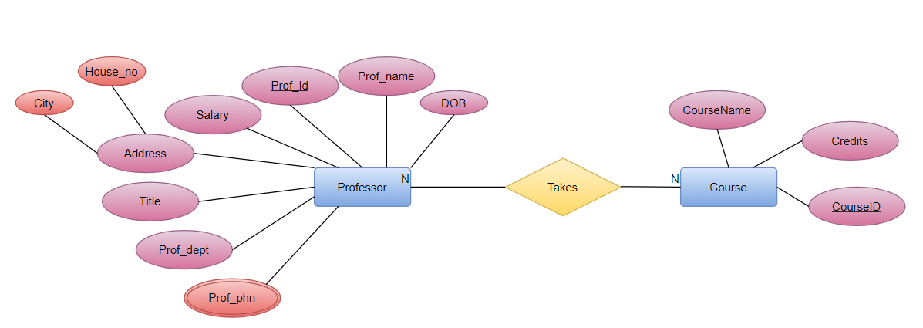**UNF:** prof_phn, prof_dept, title, address, salary, prof_id, Prof_name, DOB, CourseID, CoursesName, Credits



**1NF:**

Multivalued Attribute: prof_phn

**2NF:**

1. Pf_Phone, professorID.

2. pf_department, pf_title,pf_address,pf_salary, professorID, ProfessorName, DOB

3. CourseID, CourseName, Credits

**3NF:**

1. Prof_id, pf_Phone

2. prof_id, Prof_name, DOB, pf_dept, address

3. Prof_id, title, salary

4. CourseID, CourseName

5. CourseName, Credits

**8)Relation: Many to Many**



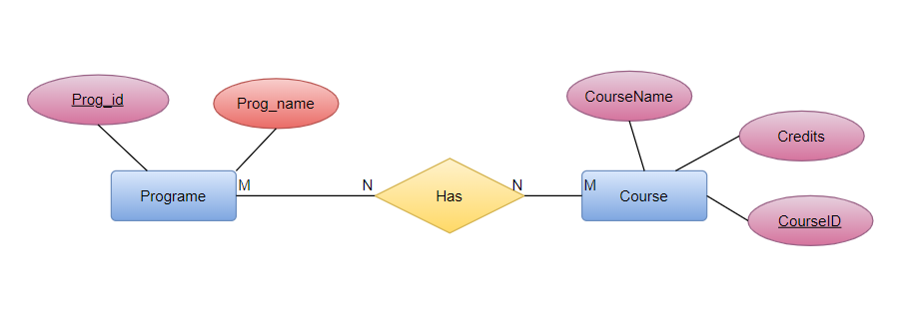



**UNF:** CourseID, CourseName, Credits, Prog_id, Prog_name

**1NF:**

The tables are already in 1NF.

**2NF:**

1. CourseID, CourseName, Credits

2. Prog_id, Prog_name

3. CourseID, Prog_id

**3NF:**

1. CourseID, CourseName

2. CourseName, Credits

3. Prog_id, Prog_name

**9)Relation: One to one**

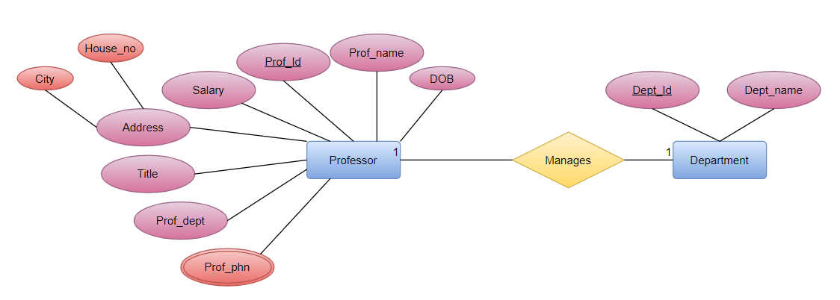

**UNF:** Prof_id, Prof_name, DOB, Salary, Address, Title, prof_dept, prof_phn,City, House_no, Dept_id, Dept_name

**1NF:**

Multivalued attribute: PfPhone

**2NF:**

1. Prof_id, Prof_name, DOB, Salary, Title, prof_dept

2. Prof_id, prof_phn

3. Dept_id, Dept_name

4. Prof_id, Dept_id

5.prof_id, City, House_no

**3NF:**

1. Prof_id, Prof_name, DOB, prof_dept

2. Prof_id, prof_phn

3. Dept_id, Dept_name

4. Prof_id, Dept_id

5. Prof_id, City, House_no

6. Prof_id, Title, Salary



**10)Relation: One to many**

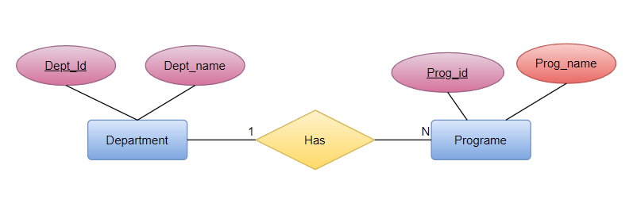

**UNF:** Dept_id, Dept_name, Prog_id, Prog_name

**1NF:**

The tables are already in 1NF.

**2NF:**

1. Dept_id, Dept_name

2. Prog_id, Prog_name, Dept_id.­

**3NF:**

No transitive dependency is available in these tables.

**11)Relation: Many to one**

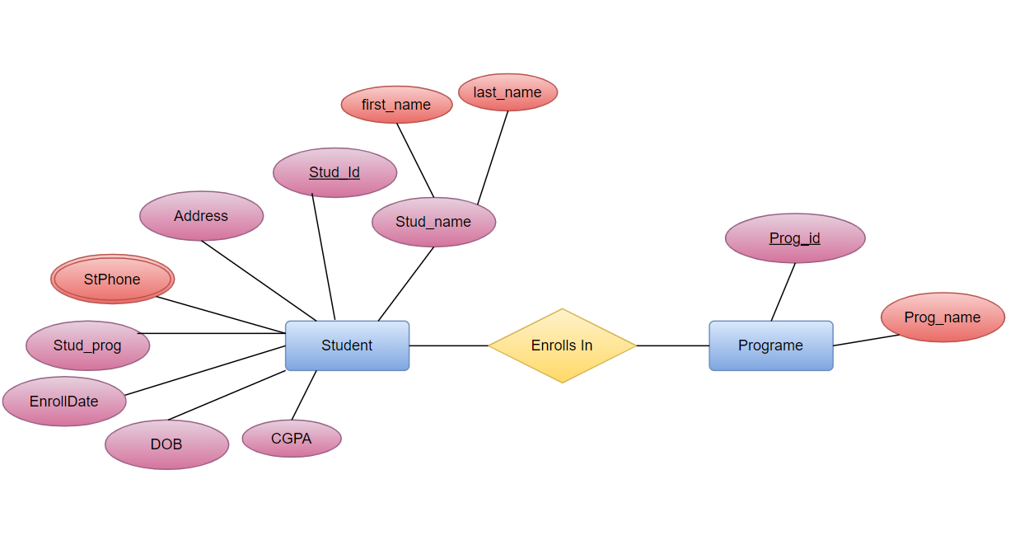

UNF: Stud_id, first_name, last_name, address, cgpa, dob, stud_prog, enrolldate, stPhone

Prog_id, prog_name

**1NF:**

Multivalued attribute: stPhone

**2NF:**

1.stud_id, first_name, last_name, address, cgpa, dob, stud_prog, enrolldate

2.stud_id, stPhone

3.stud_id, prog_id, prog_name

**3NF:**

There is no transitive dependency.

**FINALIZATION:**

1. Emp_Phone, Emp_ID
2. Prof_Phone, Prof _ID.
3. Prof_ID , city , house_no
4. Emp_ID, Emp_Name, Emp_DOB, EMP_Address, Emp_Dept
5. ~~Emp_ID,Emp_salary, Rank.~~
6. prof _ID, prof_dept, Prof_Name, DOB.
7. ~~Prof_ID,Prof_salary, prof_title.~~
8. ~~Prof_ID,Prof_salary, prof_title.~~
9. Stud_id, first_name, last_name , DOB, CGPA, Enrolldate, Stud_prog, Address
10. Stu_Phone, Stud_id
11. Degree_type, DegreeName
12. Stud_id, DegreeName
13. ~~EmpPhone, Emp_id~~
14. Emp_id, emp_name, DOB, Address, EmpPhone
15. Salary, Rank, Department, Emp_id
16. M_id, first_name, last_name, M_rank, M_division
17. ~~Stud_id, first_name, last_name, DOB, CGPA, Enrolldate, Programe, Address~~
18. St_Phone, Stud_id
19. ~~M_id, first_name, last_name , M_rank, M_division.~~
20. M_id, Stud_id
21. ~~M_id, first_name, last_name, M_rank,M_division.~~
22. M_id, DegreeName
23. ~~DegreeName, degree_type~~
24. ~~Stud_id, first_name, last_name, DOB, CGPA, Enrolldate, stud_prog, Address~~
25. ~~St_Phone, Stud_id~~
26. ~~prof_id, prof_phn~~
27. ~~prof_id, Prof_Name, DOB, prof_dept~~
28. ~~prof_id, pf_title~~
29. ~~pf_title, salary~~
30. Stud_id, prof_id
31. prof_id, city, house_no
32. ~~Prof_ID, pf_Phone~~
33. ~~prof_id, Prof_name, DOB, prof_dept, address~~
34. prof_id, title, salary
35. CourseID, CourseName
36. CourseName, Credits
37. ~~CourseID, CourseName~~
38. ~~CourseName, Credits~~
39. ~~Prog_id, Prog_name~~
40. ~~Prof_id, Prof_name, DOB, Salary, Prof_Title, prof_dept~~
41. ~~Prof_id, prof_phn~~
42. Dept_id, Dept_name
43. Prof_id, Dept_id
44. ~~Prof_id, City, House_no~~
45. ~~Prof_id, Prof_name, DOB, prof_dept~~
46. ~~Prof_id, Title, Salary~~
47. ~~Dept_id, Dept_name~~
48. Prog_id, Prog_name, Dept_id
49. ~~stud_id, first_name, last_name, address, cgpa, dob, stud_prog, enrolldate~~
50. ~~stud_id, stPhone~~
51. stud_id, prog_id, prog_name

**TABLE CREATION AND DATA INSERTION:**

**EMP Contact info Table:**

|  |  |  |
| --- | --- | --- |
| EDIT | EMP_PHONE | EMP_ID |
| [Edit](http://127.0.0.1:8080/apex/f?p=4500:47:2480312720610616:::47,SW_QBE_UPDATE:P47_RETURN_TO,F4500_P47_ID:2101,%41%41%41%44%75%64%41%41%45%41%41%41%41%47%41%41%41%41) | 1425060478 | 22-9999-3 |
| [Edit](http://127.0.0.1:8080/apex/f?p=4500:47:2480312720610616:::47,SW_QBE_UPDATE:P47_RETURN_TO,F4500_P47_ID:2101,%41%41%41%44%75%64%41%41%45%41%41%41%41%47%41%41%41%42) | 1305060478 | 22-9888-3 |
| [Edit](http://127.0.0.1:8080/apex/f?p=4500:47:2480312720610616:::47,SW_QBE_UPDATE:P47_RETURN_TO,F4500_P47_ID:2101,%41%41%41%44%75%64%41%41%45%41%41%41%41%47%41%41%41%43) | 1307862378 | 22-9896-3 |
|  |  |  |

CREATE TABLE Emp_Contacts (Emp_Phone number, Emp_ID varchar(20));

INSERT INTO Emp_Contacts VALUES (01425060478,'22-9999-3');

INSERT INTO Emp_Contacts VALUES (01305060478,'22-9888-3');

INSERT INTO Emp_Contacts VALUES (01307862378,'22-9896-3');

INSERT INTO Emp_Contacts VALUES (016078621473,'22-9896-3');

**Professor Contact Table:**

|  |  |  |
| --- | --- | --- |
| EDIT | PROF_PHONE | PROF_ID |
| [Edit](http://127.0.0.1:8080/apex/f?p=4500:47:2480312720610616:::47,SW_QBE_UPDATE:P47_RETURN_TO,F4500_P47_ID:2101,%41%41%41%44%75%65%41%41%45%41%41%41%41%47%47%41%41%41) | 145665896 | 22-8599-3 |
| [Edit](http://127.0.0.1:8080/apex/f?p=4500:47:2480312720610616:::47,SW_QBE_UPDATE:P47_RETURN_TO,F4500_P47_ID:2101,%41%41%41%44%75%65%41%41%45%41%41%41%41%47%47%41%41%42) | 152506458 | 22-9965-3 |
| [Edit](http://127.0.0.1:8080/apex/f?p=4500:47:2480312720610616:::47,SW_QBE_UPDATE:P47_RETURN_TO,F4500_P47_ID:2101,%41%41%41%44%75%65%41%41%45%41%41%41%41%47%47%41%41%43) | 1325060478 | 22-9259-3 |
| [Edit](http://127.0.0.1:8080/apex/f?p=4500:47:2480312720610616:::47,SW_QBE_UPDATE:P47_RETURN_TO,F4500_P47_ID:2101,%41%41%41%44%75%65%41%41%45%41%41%41%41%47%47%41%41%44) | 1925060236 | 22-9753-3 |

CREATE TABLE Prof_Contacts (Prof_Phone number, Prof_ID varchar(20));

INSERT INTO Prof_Contacts VALUES (0145665896,'22-8599-3');

INSERT INTO Prof_Contacts VALUES (0152506458,'22-9965-3');

INSERT INTO Prof_Contacts VALUES (01325060478,'22-9259-3');

INSERT INTO Prof_Contacts VALUES (01925060236,'22-9753-3');

**Professor Address Table:**

|  |  |  |  |
| --- | --- | --- | --- |
| EDIT | PROF_ID | CITY | HOUSE_NO |
| [Edit](http://127.0.0.1:8080/apex/f?p=4500:47:2480312720610616:::47,SW_QBE_UPDATE:P47_RETURN_TO,F4500_P47_ID:2101,%41%41%41%44%75%67%41%41%45%41%41%41%41%47%55%41%41%41) | 22-8599-3 | Dhaka | 39/H Kuril |
| [Edit](http://127.0.0.1:8080/apex/f?p=4500:47:2480312720610616:::47,SW_QBE_UPDATE:P47_RETURN_TO,F4500_P47_ID:2101,%41%41%41%44%75%67%41%41%45%41%41%41%41%47%55%41%41%42) | 22-9965-3 | Dhaka | 39/H Uttora |
| [Edit](http://127.0.0.1:8080/apex/f?p=4500:47:2480312720610616:::47,SW_QBE_UPDATE:P47_RETURN_TO,F4500_P47_ID:2101,%41%41%41%44%75%67%41%41%45%41%41%41%41%47%55%41%41%43) | 22-9259-3 | Dhaka | 39/H Banasree |
| [Edit](http://127.0.0.1:8080/apex/f?p=4500:47:2480312720610616:::47,SW_QBE_UPDATE:P47_RETURN_TO,F4500_P47_ID:2101,%41%41%41%44%75%67%41%41%45%41%41%41%41%47%55%41%41%44) | 22-9753-3 | Dhaka | 39/H Dhanmond |

CREATE TABLE Prof_Address (Prof_ID varchar(20), City varchar(20), house_no varchar(20));

INSERT INTO Prof_Address VALUES ('22-8599-3','Dhaka','39/H Kuril');

INSERT INTO Prof_Address VALUES ('22-9965-3','Dhaka','39/H Uttora');

INSERT INTO Prof_Address VALUES ('22-9259-3','Dhaka','39/H Banasree');

INSERT INTO Prof_Address VALUES ('22-9753-3','Dhaka','39/H Dhanmondi');

**EMP information Table:**

|  |  |  |  |  |  |
| --- | --- | --- | --- | --- | --- |
| EDIT | EMP_ID | EMP_NAME | EMP_DOB | EMP_ADDRESS | EMP_DEPT |
| [Edit](http://127.0.0.1:8080/apex/f?p=4500:47:2480312720610616:::47,SW_QBE_UPDATE:P47_RETURN_TO,F4500_P47_ID:2101,%41%41%41%44%75%69%41%41%45%41%41%41%41%47%6B%41%41%41) | 22-9896-3 | Mehraj | 01-MAY-95 | 39/H Banasree | Registration |
| [Edit](http://127.0.0.1:8080/apex/f?p=4500:47:2480312720610616:::47,SW_QBE_UPDATE:P47_RETURN_TO,F4500_P47_ID:2101,%41%41%41%44%75%69%41%41%45%41%41%41%41%47%6C%41%41%41) | 22-9999-3 | Asif | 01-JAN-88 | 39/H Kuril | CSE |
| [Edit](http://127.0.0.1:8080/apex/f?p=4500:47:2480312720610616:::47,SW_QBE_UPDATE:P47_RETURN_TO,F4500_P47_ID:2101,%41%41%41%44%75%69%41%41%45%41%41%41%41%47%6F%41%41%41) | 22-9888-3 | Shams | 02-MAY-90 | 39/H Uttora | EEE |
| [Edit](http://127.0.0.1:8080/apex/f?p=4500:47:2480312720610616:::47,SW_QBE_UPDATE:P47_RETURN_TO,F4500_P47_ID:2101,%41%41%41%44%75%69%41%41%45%41%41%41%41%47%6F%41%41%42) | 22-9496-3 | Amina | 01-JAN-80 | 39/H Dhanmondi | Accounting |
|  |  |  |  |  |  |

CREATE TABLE EMP_info( Emp_ID varchar(20), Emp_Name varchar(20), Emp_DOB date, EMP_Address varchar(20), Emp_Dept varchar(20));

INSERT INTO EMP_info VALUES ('22-9999-3','Asif',to_date('01-01-1988','dd-mm-yyyy'),'39/H Kuril', 'CSE');

INSERT INTO EMP_info VALUES ('22-9888-3','Shams',to_date('02-05-1990','dd-mm-yyyy'),'39/H Uttora', 'EEE');

INSERT INTO EMP_info VALUES ('22-9896-3','Mehraj',to_date('01-05-1995','dd-mm-yyyy'),'39/H Banasree', 'Registration');

INSERT INTO EMP_info VALUES ('22-9496-3','Amina',to_date('01-01-1980','dd-mm-yyyy'),'39/H Dhanmondi', 'Accounting');

**Professor Information Table:**

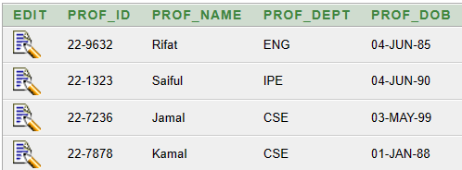

CREATE TABLE PROF_INFO(

PROF_ID VARCHAR2(20),

PROF_NAME VARCHAR2(20),

PROF_DEPT VARCHAR2(20),

PROF_DOB date

);

INSERT INTO PROF_INFO VALUES ('22-7878','Kamal','CSE',to_date('01-01-1988','dd-mm-yyyy'));

INSERT INTO PROF_INFO VALUES ('22-4578','Jamal','EEE',to_date('04-06-1987','dd-mm-yyyy'));

INSERT INTO PROF_INFO VALUES ('22-1323','Saiful','IPE',to_date('04-06-1990','dd-mm-yyyy'));

INSERT INTO PROF_INFO VALUES ('22-9632','Rifat','ENG',to_date('04-06-1985','dd-mm-yyyy'));

**STUD_INFO**

|  |  |  |  |  |  |  |  |  |
| --- | --- | --- | --- | --- | --- | --- | --- | --- |
| **EDIT** | **STUD_ID** | **FIRST_NAME** | **LAST_NAME** | **DOB** | **CGPA** | **ENROLLDATE** | **PROGRAM** | **ADDRESS** |
| [Edit](http://127.0.0.1:8080/apex/f?p=4500:47:4397206271526209:::47,SW_QBE_UPDATE:P47_RETURN_TO,F4500_P47_ID:2101,%41%41%41%44%57%76%41%41%45%41%41%41%41%46%74%41%41%41) | 20-37236-3 | Fardin | Rahman | 12-Sep | 3.8 | 02-Jan | CSE | DOHS |
| [Edit](http://127.0.0.1:8080/apex/f?p=4500:47:4397206271526209:::47,SW_QBE_UPDATE:P47_RETURN_TO,F4500_P47_ID:2101,%41%41%41%44%57%76%41%41%45%41%41%41%41%46%75%41%41%41) | 22-48895-3 | Rubaiyat | Islam | 10-Aug | 4 | 12-Sep | CSE | Mirpur |
| [Edit](http://127.0.0.1:8080/apex/f?p=4500:47:4397206271526209:::47,SW_QBE_UPDATE:P47_RETURN_TO,F4500_P47_ID:2101,%41%41%41%44%57%76%41%41%45%41%41%41%41%46%77%41%41%41) | 18-25271-3 | Tahmeed | Islam | 07-Jun | 3.9 | 05-Jun | EEE | Pallabi |
| [Edit](http://127.0.0.1:8080/apex/f?p=4500:47:4397206271526209:::47,SW_QBE_UPDATE:P47_RETURN_TO,F4500_P47_ID:2101,%41%41%41%44%57%76%41%41%45%41%41%41%41%46%77%41%41%42) | 19-57421-1 | Nafi | Khan | 26-Aug | 2.3 | 3-Sep | BBA | Mirpur |

create table Stud_info (Stud_id varchar (10), first_name varchar (10), last_name varchar (10), dob varchar (10), cgpa float (5), enrolldate varchar (10), program varchar (10), address varchar (10));

insert into Stud_info values ('22-48895-3', 'Rubaiyat', 'Islam', '10-Aug', 4.00, '12-Sep', 'CSE', 'Mirpur')

insert into Stud_info values ('20-37236-3', 'Fardin', 'Rahman', '12-Sep', 3.80, '02-Jan', 'CSE', 'DOHS')

insert into Stud_info values ('18-25271-3', 'Tahmeed', 'Islam', '07-Jun', 3.90, '05-Jun', 'EEE', 'Pallabi')

**Student – Phone Table:**

|  |  |  |
| --- | --- | --- |
| **EDIT** | **STUD_ID** | **STUD_PHONE** |
| [Edit](http://127.0.0.1:8080/apex/f?p=4500:47:2792363540991183:::47,SW_QBE_UPDATE:P47_RETURN_TO,F4500_P47_ID:2101,%41%41%41%44%68%4A%41%41%45%41%41%41%41%46%4F%41%41%41) | 22-49302 | 01324314139 |
| [Edit](http://127.0.0.1:8080/apex/f?p=4500:47:2792363540991183:::47,SW_QBE_UPDATE:P47_RETURN_TO,F4500_P47_ID:2101,%41%41%41%44%68%4A%41%41%45%41%41%41%41%46%4F%41%41%42) | 22-49303 | 01324314140 |
| [Edit](http://127.0.0.1:8080/apex/f?p=4500:47:2792363540991183:::47,SW_QBE_UPDATE:P47_RETURN_TO,F4500_P47_ID:2101,%41%41%41%44%68%4A%41%41%45%41%41%41%41%46%4F%41%41%43) | 22-49304 | 01324314141 |
| [Edit](http://127.0.0.1:8080/apex/f?p=4500:47:2792363540991183:::47,SW_QBE_UPDATE:P47_RETURN_TO,F4500_P47_ID:2101,%41%41%41%44%68%4A%41%41%45%41%41%41%41%46%50%41%41%41) | 22-49301 | 01324314138 |

create table student_phone (stud_id varchar(25), stud_phone varchar(11) );

insert into student_phone values ('22-49301','01324314138');

insert into student_phone values ('22-49302','01324314139');

insert into student_phone values ('22-49303','01324314140');

insert into student_phone values ('22-49304','01324314141');

**Degree Table:**

|  |  |  |
| --- | --- | --- |
| **EDIT** | **DEGREE_TYPE** | **DEGREENAME** |
| [Edit](http://127.0.0.1:8080/apex/f?p=4500:47:2792363540991183:::47,SW_QBE_UPDATE:P47_RETURN_TO,F4500_P47_ID:2101,%41%41%41%44%68%4B%41%41%45%41%41%41%41%46%55%41%41%41) | undergraduate | bsc |
| [Edit](http://127.0.0.1:8080/apex/f?p=4500:47:2792363540991183:::47,SW_QBE_UPDATE:P47_RETURN_TO,F4500_P47_ID:2101,%41%41%41%44%68%4B%41%41%45%41%41%41%41%46%55%41%41%42) | undergraduate | bba |
| [Edit](http://127.0.0.1:8080/apex/f?p=4500:47:2792363540991183:::47,SW_QBE_UPDATE:P47_RETURN_TO,F4500_P47_ID:2101,%41%41%41%44%68%4B%41%41%45%41%41%41%41%46%55%41%41%43) | postgraduate | msc |

create table degree (

degree_type varchar(15),

degreename varchar(25)

);

insert into degree values ('undergraduate','bsc');

insert into degree values ('undergraduate','bba');

insert into degree values ('postgraduate','msc');

**Student - Degree Table:**

|  |  |  |
| --- | --- | --- |
| **EDIT** | **STUD_ID** | **DEGREENAME** |
| [Edit](http://127.0.0.1:8080/apex/f?p=4500:47:2792363540991183:::47,SW_QBE_UPDATE:P47_RETURN_TO,F4500_P47_ID:2101,%41%41%41%44%68%4C%41%41%45%41%41%41%41%46%64%41%41%41) | 22-49301 | bsc |
| [Edit](http://127.0.0.1:8080/apex/f?p=4500:47:2792363540991183:::47,SW_QBE_UPDATE:P47_RETURN_TO,F4500_P47_ID:2101,%41%41%41%44%68%4C%41%41%45%41%41%41%41%46%64%41%41%42) | 22-49302 | msc |
| [Edit](http://127.0.0.1:8080/apex/f?p=4500:47:2792363540991183:::47,SW_QBE_UPDATE:P47_RETURN_TO,F4500_P47_ID:2101,%41%41%41%44%68%4C%41%41%45%41%41%41%41%46%64%41%41%43) | 22-49303 | bba |

create table stu_degree (

stud_id varchar(25),

degreename varchar(25)

);

insert into stu_degree values ('22-49301','bsc');

insert into stu_degree values ('22-49302','msc');

insert into stu_degree values ('22-49303','bba');

**Employee Table:**

|  |  |  |  |  |
| --- | --- | --- | --- | --- |
| **EDIT** | **EMP_ID** | **EMP_NAME** | **DOB** | **ADDRESS** |
| [Edit](http://127.0.0.1:8080/apex/f?p=4500:47:2792363540991183:::47,SW_QBE_UPDATE:P47_RETURN_TO,F4500_P47_ID:2101,%41%41%41%44%68%4D%41%41%45%41%41%41%41%46%6C%41%41%41) | 100-001 | yeren | 01-JAN-23 | dhaka |
| [Edit](http://127.0.0.1:8080/apex/f?p=4500:47:2792363540991183:::47,SW_QBE_UPDATE:P47_RETURN_TO,F4500_P47_ID:2101,%41%41%41%44%68%4D%41%41%45%41%41%41%41%46%6C%41%41%42) | 100-002 | yeger | 02-JAN-23 | mymenshingh |
| [Edit](http://127.0.0.1:8080/apex/f?p=4500:47:2792363540991183:::47,SW_QBE_UPDATE:P47_RETURN_TO,F4500_P47_ID:2101,%41%41%41%44%68%4D%41%41%45%41%41%41%41%46%6C%41%41%43) | 100-003 | ramiraze | 03-JAN-23 | rajshahi |
| [Edit](http://127.0.0.1:8080/apex/f?p=4500:47:2792363540991183:::47,SW_QBE_UPDATE:P47_RETURN_TO,F4500_P47_ID:2101,%41%41%41%44%68%4D%41%41%45%41%41%41%41%46%6C%41%41%44) | 100-004 | midas | 04-JAN-23 | sylhet |

create table employee (emp_id varchar(25), emp_name varchar(25), dob date, address varchar(25));

insert into employee values ('100-001','yeren',to_date('01-01-2023','dd-mm-yyyy'),'dhaka');

insert into employee values ('100-002','yeger',to_date('02-01-2023','dd-mm-yyyy'),'mymenshingh');

insert into employee values ('100-003','ramiraze',to_date('03-01-2023','dd-mm-yyyy'),'rajshahi');

insert into employee values ('100-004','midas',to_date('04-01-2023','dd-mm-yyyy'),'sylhet');

**Employee Salary Table:**

|  |  |  |  |
| --- | --- | --- | --- |
| **EDIT** | **EMP_ID** | **RANK** | **SALARY** |
| [Edit](http://127.0.0.1:8080/apex/f?p=4500:47:2792363540991183:::47,SW_QBE_UPDATE:P47_RETURN_TO,F4500_P47_ID:2101,%41%41%41%44%68%4E%41%41%45%41%41%41%41%46%73%41%41%41) | 100-001 | assistant professor | 450000 |
| [Edit](http://127.0.0.1:8080/apex/f?p=4500:47:2792363540991183:::47,SW_QBE_UPDATE:P47_RETURN_TO,F4500_P47_ID:2101,%41%41%41%44%68%4E%41%41%45%41%41%41%41%46%73%41%41%42) | 100-002 | professor | 650000 |
| [Edit](http://127.0.0.1:8080/apex/f?p=4500:47:2792363540991183:::47,SW_QBE_UPDATE:P47_RETURN_TO,F4500_P47_ID:2101,%41%41%41%44%68%4E%41%41%45%41%41%41%41%46%73%41%41%43) | 100-003 | lecturer | 400000 |
| [Edit](http://127.0.0.1:8080/apex/f?p=4500:47:2792363540991183:::47,SW_QBE_UPDATE:P47_RETURN_TO,F4500_P47_ID:2101,%41%41%41%44%68%4E%41%41%45%41%41%41%41%46%73%41%41%44) | 100-004 | senior professor | 750000 |
|  |  |  |  |

create table emp_salary(emp_id varchar(25), rank varchar(25), salary number);

insert into emp_salary values ('100-001','assistant professor',450000);

insert into emp_salary values ('100-002','professor',650000);

insert into emp_salary values ('100-003','lecturer',400000);

insert into emp_salary values ('100-004','senior professor',750000);

**STUDENTENROLL**

|  |  |  |
| --- | --- | --- |
| **EDIT** | **MANAGEMENT_ID** | **STUD_ID** |
|  | 28366-13 | 22-48276-1 |
|  | 28333-10 | 21-45611-2 |
|  | 27836-19 | 22-48899-3 |
|  | 26285-19 | 22-48888-3 |

create table StudentEnroll(management_id varchar(10), stud_id varchar(10));

insert into StudentEnroll values('27836-19', '22-48899-3')

insert into StudentEnroll values('26285-19', '22-48888-3')

insert into StudentEnroll values('28366-13', '22-48276-1')

insert into StudentEnroll values('28333-10', '21-45611-2')

**MANAGEMENT_INFO**

|  |  |  |  |  |  |
| --- | --- | --- | --- | --- | --- |
| **EDIT** | **M_ID** | **FIRST_NAME** | **LAST_NAME** | **M_RANK** | **M_DIVISION** |
|  | 26688-21 | Atik | Rahman | Supervisor | Registration |
|  | 22683-11 | Sifat | Ullah | Administrator | Accounting |
|  | 22962-14 | Rahmat | Jamal | Administrator | Operative |
|  | 20027-08 | Shoikot | Ismail | Manager | Operative |

create table management_info(m_id varchar(10), first_name varchar(10), last_name varchar(10), m_rank varchar(20), m_division varchar(20))

insert into management_info values('26688-21', 'Atik', 'Rahman', 'Supervisor', 'Registration')

insert into management_info values('22683-11', 'Sifat', 'Ullah', 'Administrator', 'Accounting')

insert into management_info values('22962-14', 'Rahmat', 'Jamal', 'Administrator', 'Operative')

insert into management_info values('20027-08', 'Shoikot', 'Ismail', 'Manager', 'Operative')

**DEGREES_AWARDED**

|  |  |  |
| --- | --- | --- |
| **EDIT** | **M_ID** | **DEGREE_NAME** |
|  | 27448-11 | BSc |
|  | 27365-12 | MSc |
|  | 27344-12 | MSc |
|  | 23651-10 | BBA |

create table degrees_awarded(m_id varchar(10), degree_name varchar(10));

insert into degrees_awarded values('27448-11', 'BSc')

insert into degrees_awarded values('27365-12', 'MSc')

insert into degrees_awarded values('27344-12', 'MSc')

insert into degrees_awarded values('23651-10', 'BBA')

**STUDENT_CONTACT**

|  |  |  |
| --- | --- | --- |
| **EDIT** | **STUD_ID** | **STUD_PHN** |
|  | 19-27433-3 | 01944735398 |
|  | 22-44772-3 | 01583764553 |
|  | 22-44663-1 | 01744863972 |
|  | 22-36283-3 | 01672849566 |

create table student_contact (stud_id varchar (10), stud_phn varchar(20));

insert into student_contact values ('22-44663-1', '01744863972')

insert into student_contact values ('22-36283-3', '01672849566')

insert into student_contact values ('19-27433-3', '01944735398')

insert into student_contact values ('22-44772-3', '01583764553')

**STUD_PROF**

|  |  |  |
| --- | --- | --- |
| **EDIT** | **STUD_ID** | **PROF_ID** |
|  | 22-46672-1 | 22-4617 |
|  | 21-36619-1 | 19-7727 |
|  | 20-36619-3 | 17-2711 |
|  | 20-17669-3 | 22-1592 |

create table stud_prof(stud_id varchar(10), prof_id varchar(10))

insert into stud_prof values('22-46672-1', '22-4617')

insert into stud_prof values('21-36619-1', '19-7727')

insert into stud_prof values('20-36619-3', '17-2711')

insert into stud_prof values('20-17669-3', '22-1592')

**PROF_ADDRESS**

|  |  |  |  |
| --- | --- | --- | --- |
| **EDIT** | **PROF_ID** | **CITY** | **HOUSENO** |
|  | 22-4628 | Mirpur | 54C |
|  | 22-2868 | ECB | 22A |
|  | 20-2665 | Shamoli | 34L |
|  | 22-3681 | Farmgate | 86A |

create table prof_address (Prof_id varchar (10), city varchar(10), houseno varchar(10));

insert into prof_address values ('22-4628', 'Mirpur', '54C')

insert into prof_address values ('22-2868', 'ECB', '22A')

insert into prof_address values ('20-2665', 'Shamoli', '34L')

insert into prof_address values ('22-3681', 'Farmgate', '86A')

**PROF_SAL**

|  |  |  |  |
| --- | --- | --- | --- |
| **EDIT** | **PROF_ID** | **TITLE** | **SALARY** |
|  | 22-1637 | Assistant | 20000 |
|  | 22-2715 | Assistant | 30000 |
|  | 22-2751 | Associate | 20000 |
|  | 22-2671 | Lecturer | 20000 |

create table prof_sal(prof_id varchar(10), title varchar(10), salary number (10));

insert into prof_sal values ('22-1637', 'Assistant', '20000')

insert into prof_sal values ('22-2715', 'Assistant', '30000')

insert into prof_sal values ('22-2751', 'Associate', '20000')

insert into prof_sal values ('22-2671', 'Lecturer', '20000')

**Table Name: Department**

|  |  |
| --- | --- |
| **COURSEID** | **COURSENAME** |
| 22-49363-3 | IDB |
| 22-42421-3 | ICS |
| 22-49221-3 | Algorithms |
| 22-49158-3 | Economics |

CREATE TABLE Course (CourseID varchar(10), CourseName varchar(80));

INSERT INTO Course (CourseID, CourseName) VALUES ('22-49363-3', 'IDB');

INSERT INTO Course (CourseID, CourseName) VALUES ('22-42421-3', 'ICS');

INSERT INTO Course (CourseID, CourseName) VALUES ('22-49221-3', 'Algorithms');

INSERT INTO Course (CourseID, CourseName) VALUES ('22-49158-3', 'Economics');

**Table Name: CourseCredits**

|  |  |
| --- | --- |
| **COURSENAME** | **CREDITS** |
| IDB | 3 |
| DS LAB | 1 |
| Algorithms | 3 |
| Economics | 3 |

CREATE TABLE CourseCredits (CourseName varchar(80), Credits number(1));

INSERT INTO CourseCredits (CourseName, Credits) VALUES ('IDB', 3);

INSERT INTO CourseCredits (CourseName, Credits) VALUES ('DS LAB', 1);

INSERT INTO CourseCredits (CourseName, Credits) VALUES ('Algorithms', 3);

INSERT INTO CourseCredits (CourseName, Credits) VALUES ('Economics', 3);

**Table Name: Department**

|  |  |
| --- | --- |
| **DEPT_ID** | **DEPT_NAME** |
| A1 | Department of CSE |
| A2 | Department of EEE |
| A3 | Department of IPE |
| A4 | Department of BBA |

CREATE TABLE Department (

Dept_id varchar(10),

Dept_name varchar(80));

INSERT INTO Department (Dept_id, Dept_name)

VALUES ('A1', 'Department of CSE');

INSERT INTO Department (Dept_id, Dept_name)

VALUES ('A2', 'Department of EEE');

INSERT INTO Department (Dept_id, Dept_name)

VALUES ('A3', 'Department of IPE');

INSERT INTO Department (Dept_id, Dept_name)

VALUES ('A4', 'Department of BBA');

**Table Name: ProfessorDepartment**

|  |  |
| --- | --- |
| **PROF_ID** | **DEPT_ID** |
| 11-2586 | A1 |
| 11-2554 | A2 |
| 11-2547 | A3 |
| 11-2569 | A4 |

CREATE TABLE ProfessorDepartment (

Prof_id varchar(10),

Dept_id varchar(10));

INSERT INTO ProfessorDepartment (Prof_id, Dept_id)

VALUES ('11-2586', 'A1');

INSERT INTO ProfessorDepartment (Prof_id, Dept_id)

VALUES ('11-2554', 'A2');

INSERT INTO ProfessorDepartment (Prof_id, Dept_id)

VALUES ('11-2547', 'A3');

INSERT INTO ProfessorDepartment (Prof_id, Dept_id)

VALUES ('11-2569', 'A4');

**Table Name: DepartmentProgram**

|  |  |  |
| --- | --- | --- |
| **PROG_ID** | **PROG_NAME** | **DEPT_ID** |
| B1 | IDB | A1 |
| B2 | ICS Lab | A2 |
| B3 | Algorithms | A3 |
| B4 | DS | A4 |

CREATE TABLE DepartmentProgram (

Prog_id varchar(10),

Prog_name varchar(80),

Dept_id varchar(10));

INSERT INTO DepartmentProgram (Prog_id, Prog_name, Dept_id)

VALUES ('B1', 'IDB', 'A1');

INSERT INTO DepartmentProgram (Prog_id, Prog_name, Dept_id)

VALUES ('B2', 'ICS Lab', 'A2');

INSERT INTO DepartmentProgram (Prog_id, Prog_name, Dept_id)

VALUES ('B3', 'Algorithms', 'A3');

INSERT INTO DepartmentProgram (Prog_id, Prog_name, Dept_id)

VALUES ('B4', 'DS', 'A4');

**Table Name: StudentProgram**

|  |  |  |
| --- | --- | --- |
| **STUD_ID** | **PROG_ID** | **PROG_NAME** |
| 22-49363-3 | B1 | IDB |
| 22-49322-3 | B2 | ICS |
| 22-49348-3 | B3 | Algorithms |
| 22-49369-3 | B4 | TOC |

CREATE TABLE StudentProgram (

stud_id varchar(10),

Prog_id varchar(10),

Prog_name varchar(80));

INSERT INTO StudentProgram (stud_id, Prog_id, Prog_name)

VALUES ('22-49363-3', 'B1', 'IDB');

INSERT INTO StudentProgram (stud_id, Prog_id, Prog_name)

VALUES ('22-49322-3', 'B2', 'ICS');

INSERT INTO StudentProgram (stud_id, Prog_id, Prog_name)

VALUES ('22-49348-3', 'B3', 'Algorithms');

INSERT INTO StudentProgram (stud_id, Prog_id, Prog_name)

VALUES ('22-49369-3', 'B4', 'TOC');

**Query Simple:**

**1.** Display all the records in the professor contact table:select * from PROF_CONTACTS;

2. Display prof name from english department.

**select PROF_NAME from PROF_INFO where PROF_DEPT = 'ENG';**

**Query Complex:**

1. Display all records from employee information table where he first letter of EMP_NAME is ‘M’

**select * from EMP_INFO where EMP_NAME like 'M%';**

1. Display all PROF_INFO details who born before 04-JUN-95?

**select * from PROF_INFO where PROF_DOB <= to_date('04-01-1990','dd-mm-yyyy');**

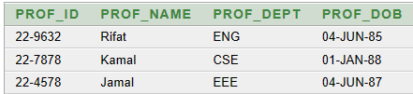

**Sub-Query:**

**1.Find all information from employee who has maximum salary.**

select * from employee where emp_id = (select emp_id from emp_salary where salary = (select max(salary) from emp_salary));



**Function:**

**1.which is the maximum salary for an employee?**

select max(salary) from emp_salary;



**2.which is the avarage salary for an employee?**

select avg(salary) from emp_salary;



**3.which is the minimum salary for an employee?**

select min(salary) from emp_salary;



**Group By:**

1. **What is the maximum salary of the employees' group by their deparment?**

SELECT MAX (Salary)

FROM Employee

GROUP BY Department;

1. **What is the average salary of professors group by the department?**

SELECT AVG(Salary)

FROM Professor

GROUP BY Department;

**Conclusion:**

In conclusion, the university management system will provide a centralized system for storing and managing information about students, managements, professors, departments, courses, programs, departments, employees and degrees. The system will allow users to generate reports, search and filter information, and create, update, delete records as necessary. All kinds of normalizations were done properly so no data will be lost while working with this management system. This project will be implemented using Oracle 10G.

In summary, by creating a unified repository for storing and managing a wealth of critical information, including details about students, faculty, departments, courses, programs, employees, and degrees, this system addresses the multifaceted needs of modern university management.